Whoami:

It shows who logged on this system.

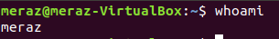

Hostname:

It tells on which machine you are

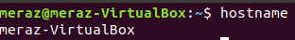

pwd:

shows the path of current directory

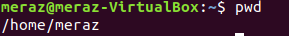

ls:

display the list of file in the current working directory.

Mkdir:

use mkdir command to make a new directory.if you type mkdir music it will create a directory called music.

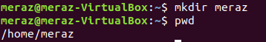

Touch:
touch command allows you to create a new blank file through the linux command line.

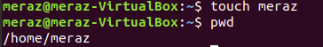

Cat:
It is used to list the content of a file on the standard output.TO fun this command type cat by followed file name.

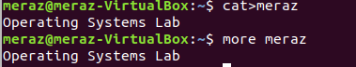

Cd:
To nevigate through linux file and directories use the cd command.It requires either the full path or the name of the directory.

